**LAY OUT TITIK GUAR TOUR AREA THE VIDA**

**ROOFTOP**

TITIK GUARDTOUR ROOFTOP UTARA (BLOWER) TITIK GUARDTOUR ROOFTOP SELATAN

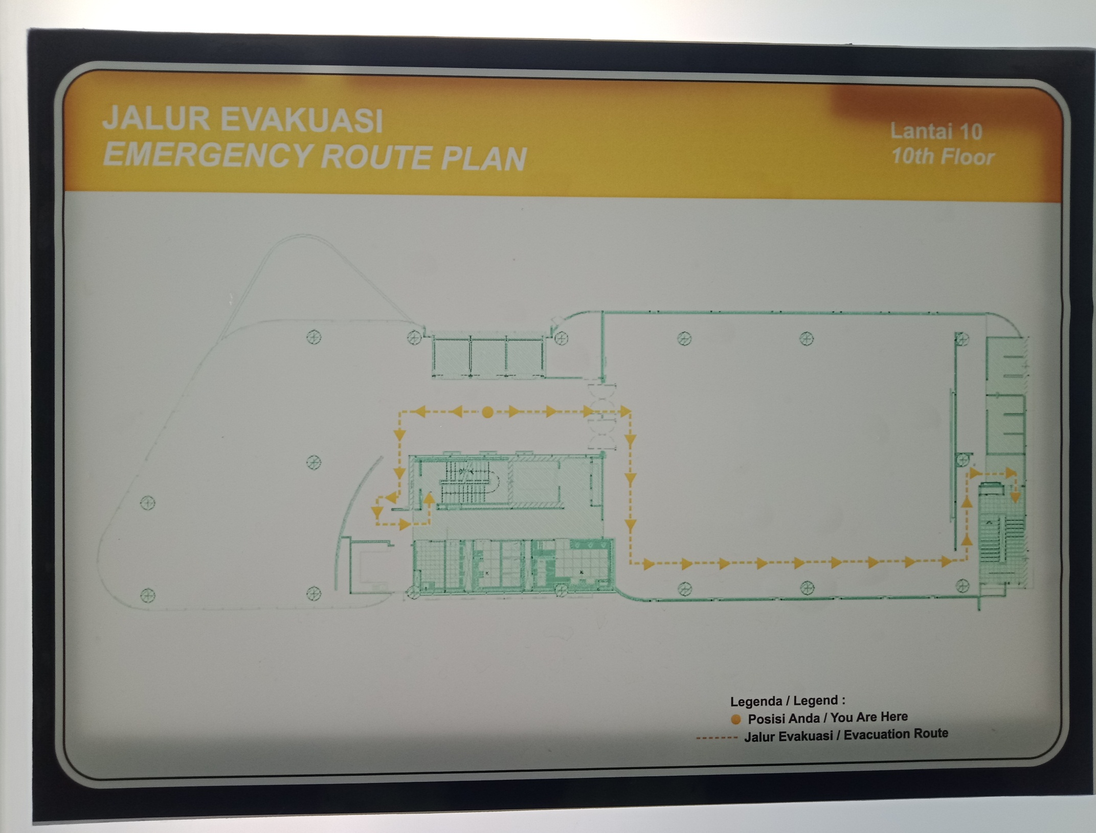

Titik GuardTour/

AREA FOYER

Titik GuardTour/

EXIT SELATAN

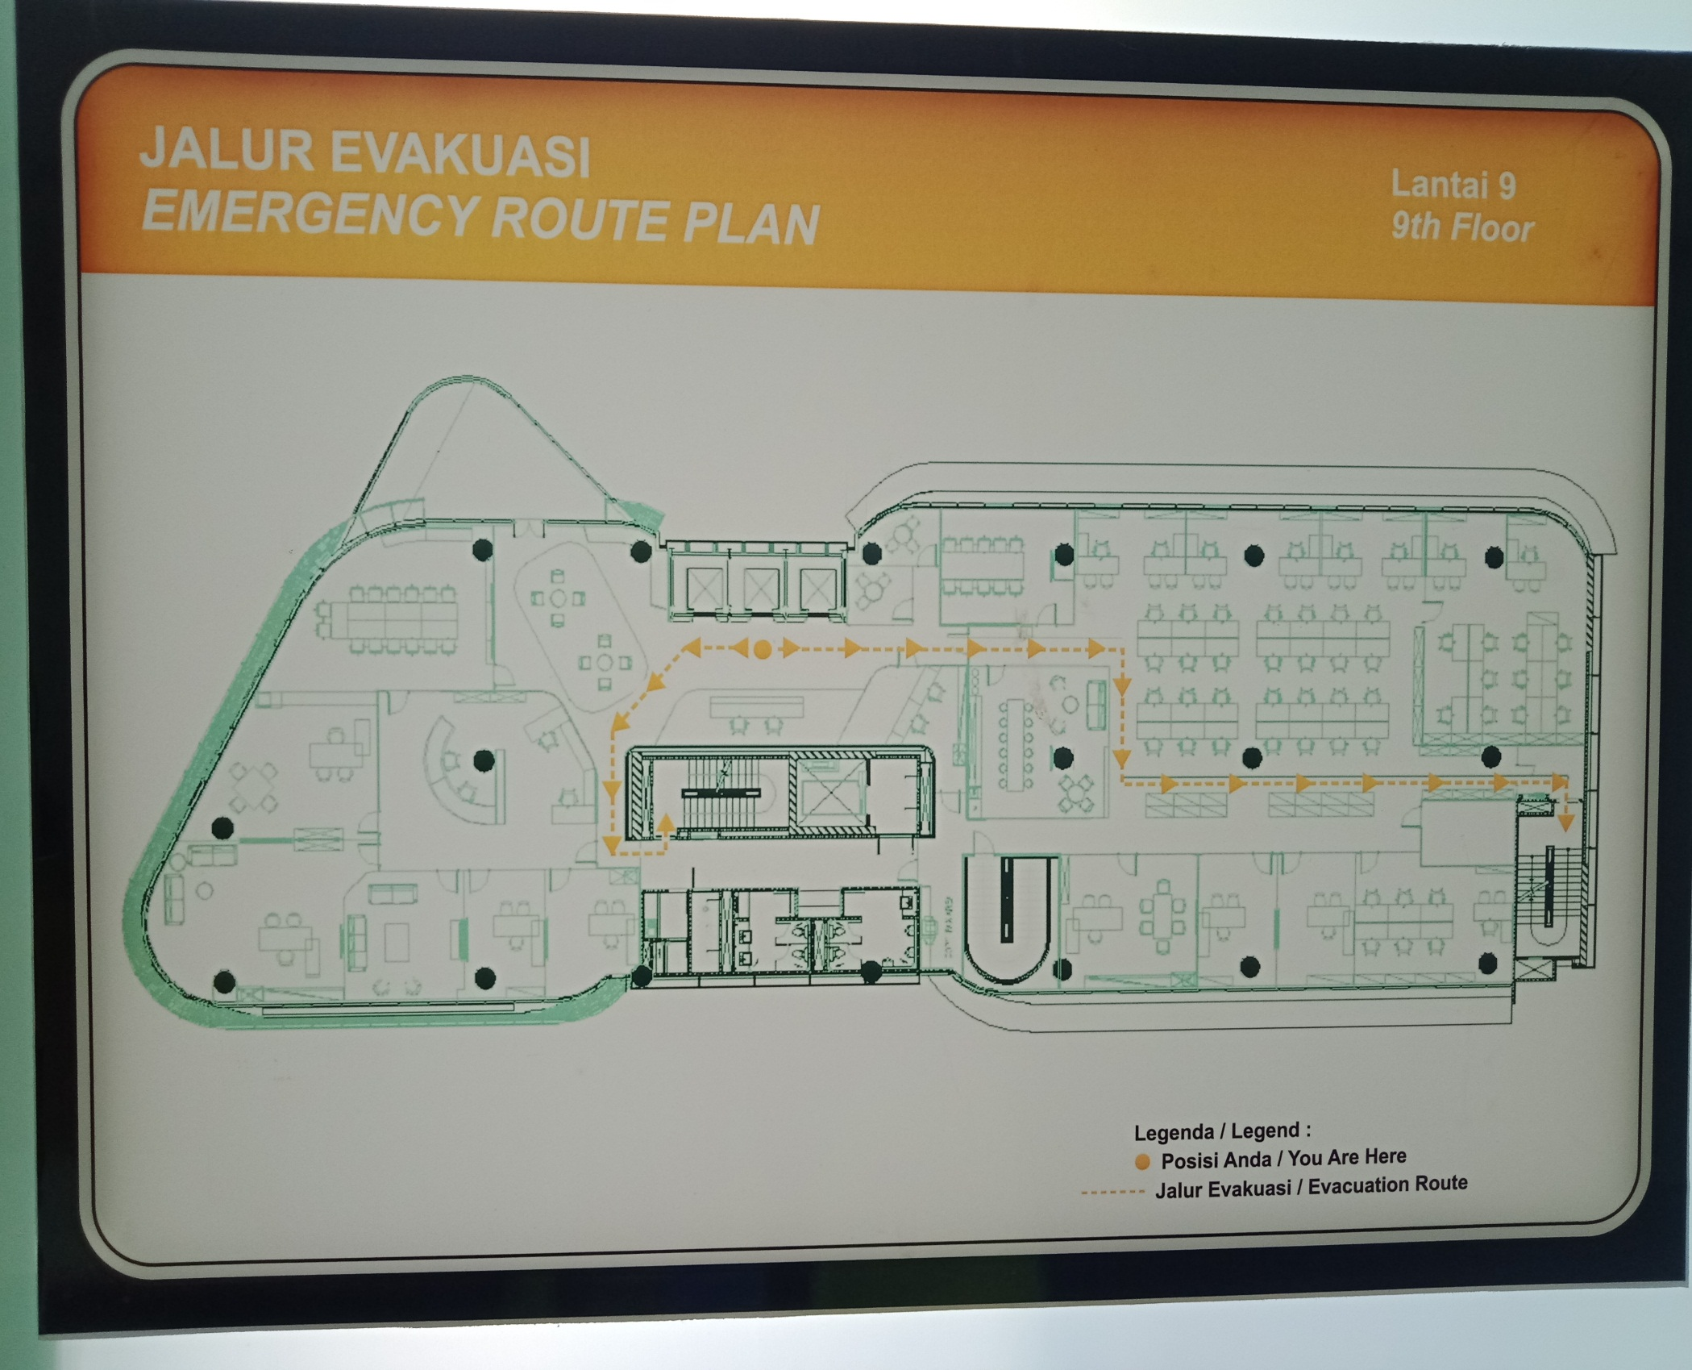

Titik GuardTour/

RUANG PANTRY

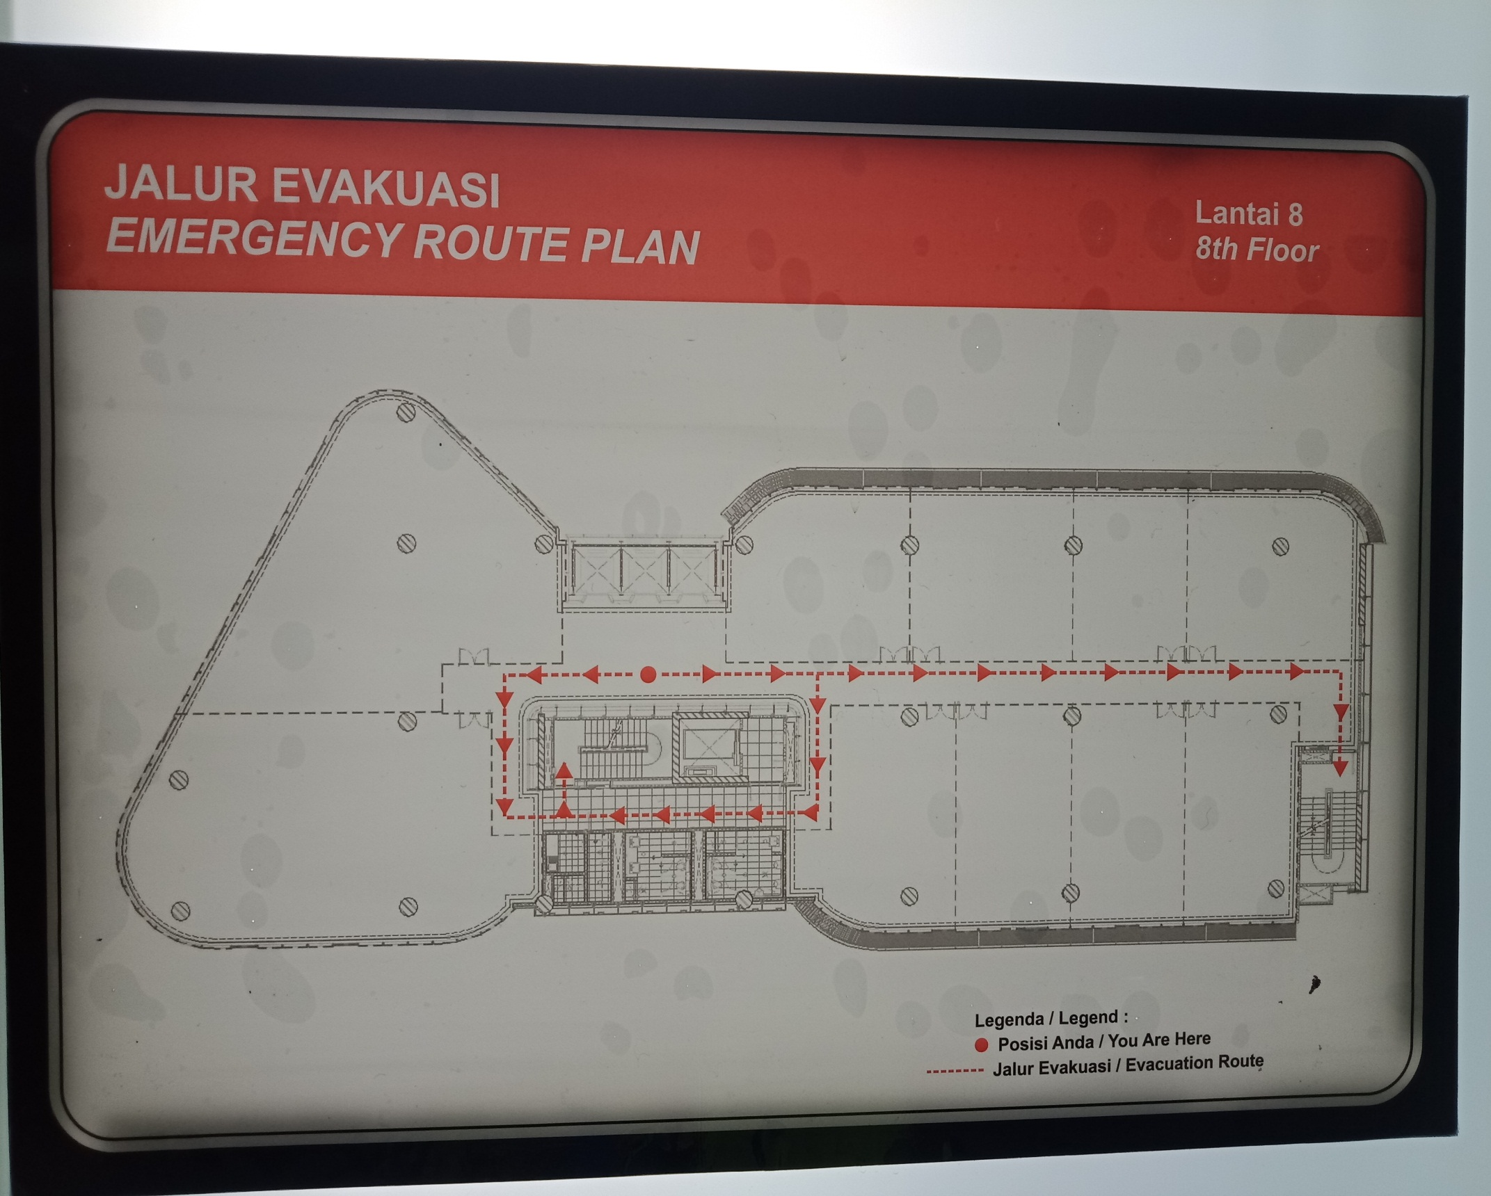

Titik GuardTour/

Ruang Pantry

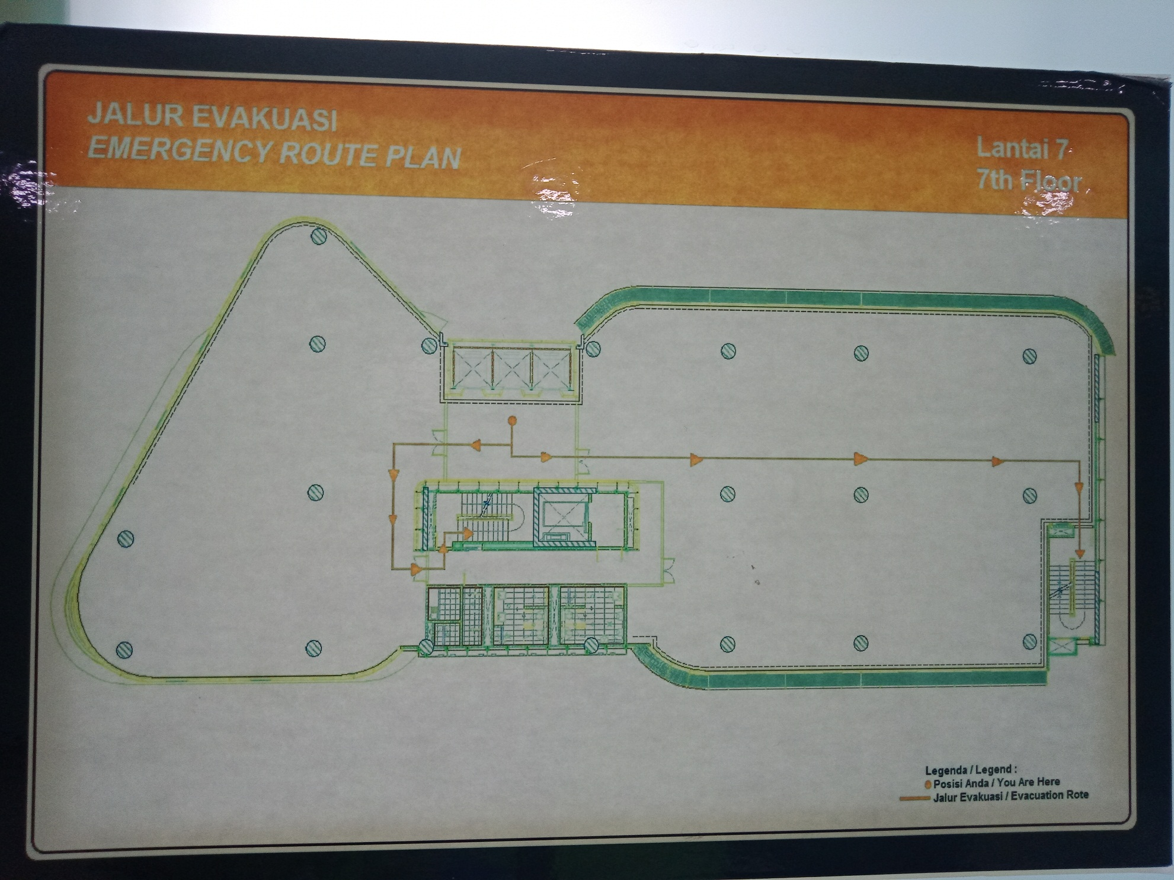

Titik GuardTour/

Ruang Pantry

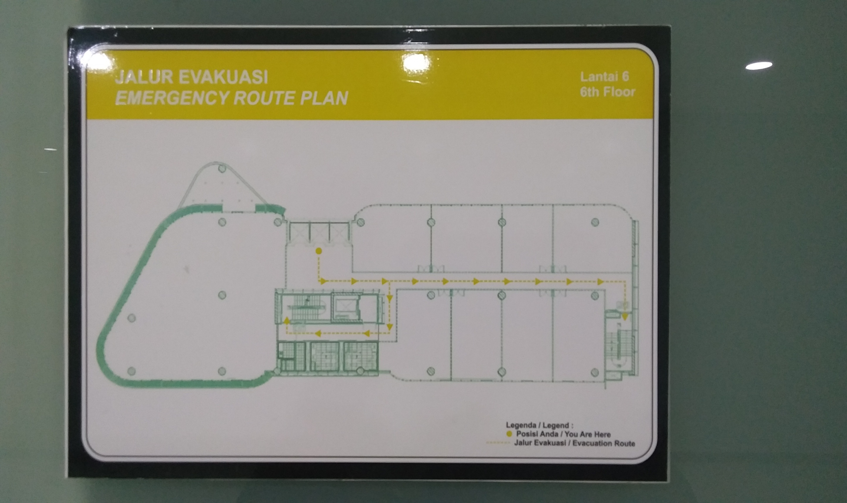

Titik GuardTour/

Ruang Pantry

Titik GuardTour/

Ruang Pantry

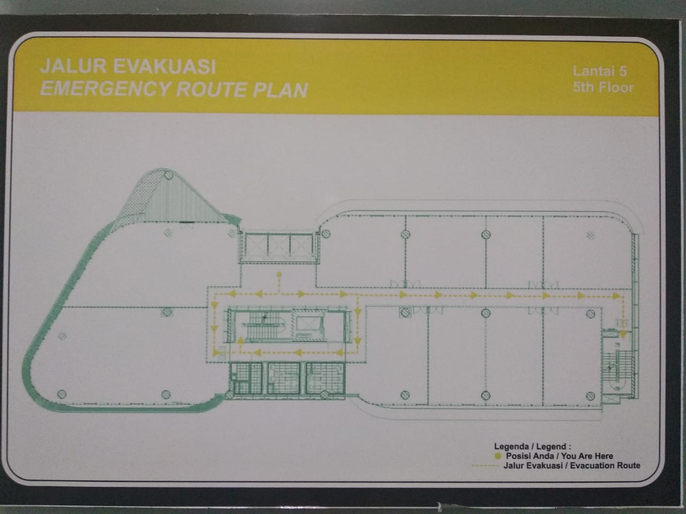

Titik GuardTour/

Exit Selatan

Titik GuardTour/

Ruang Pantry

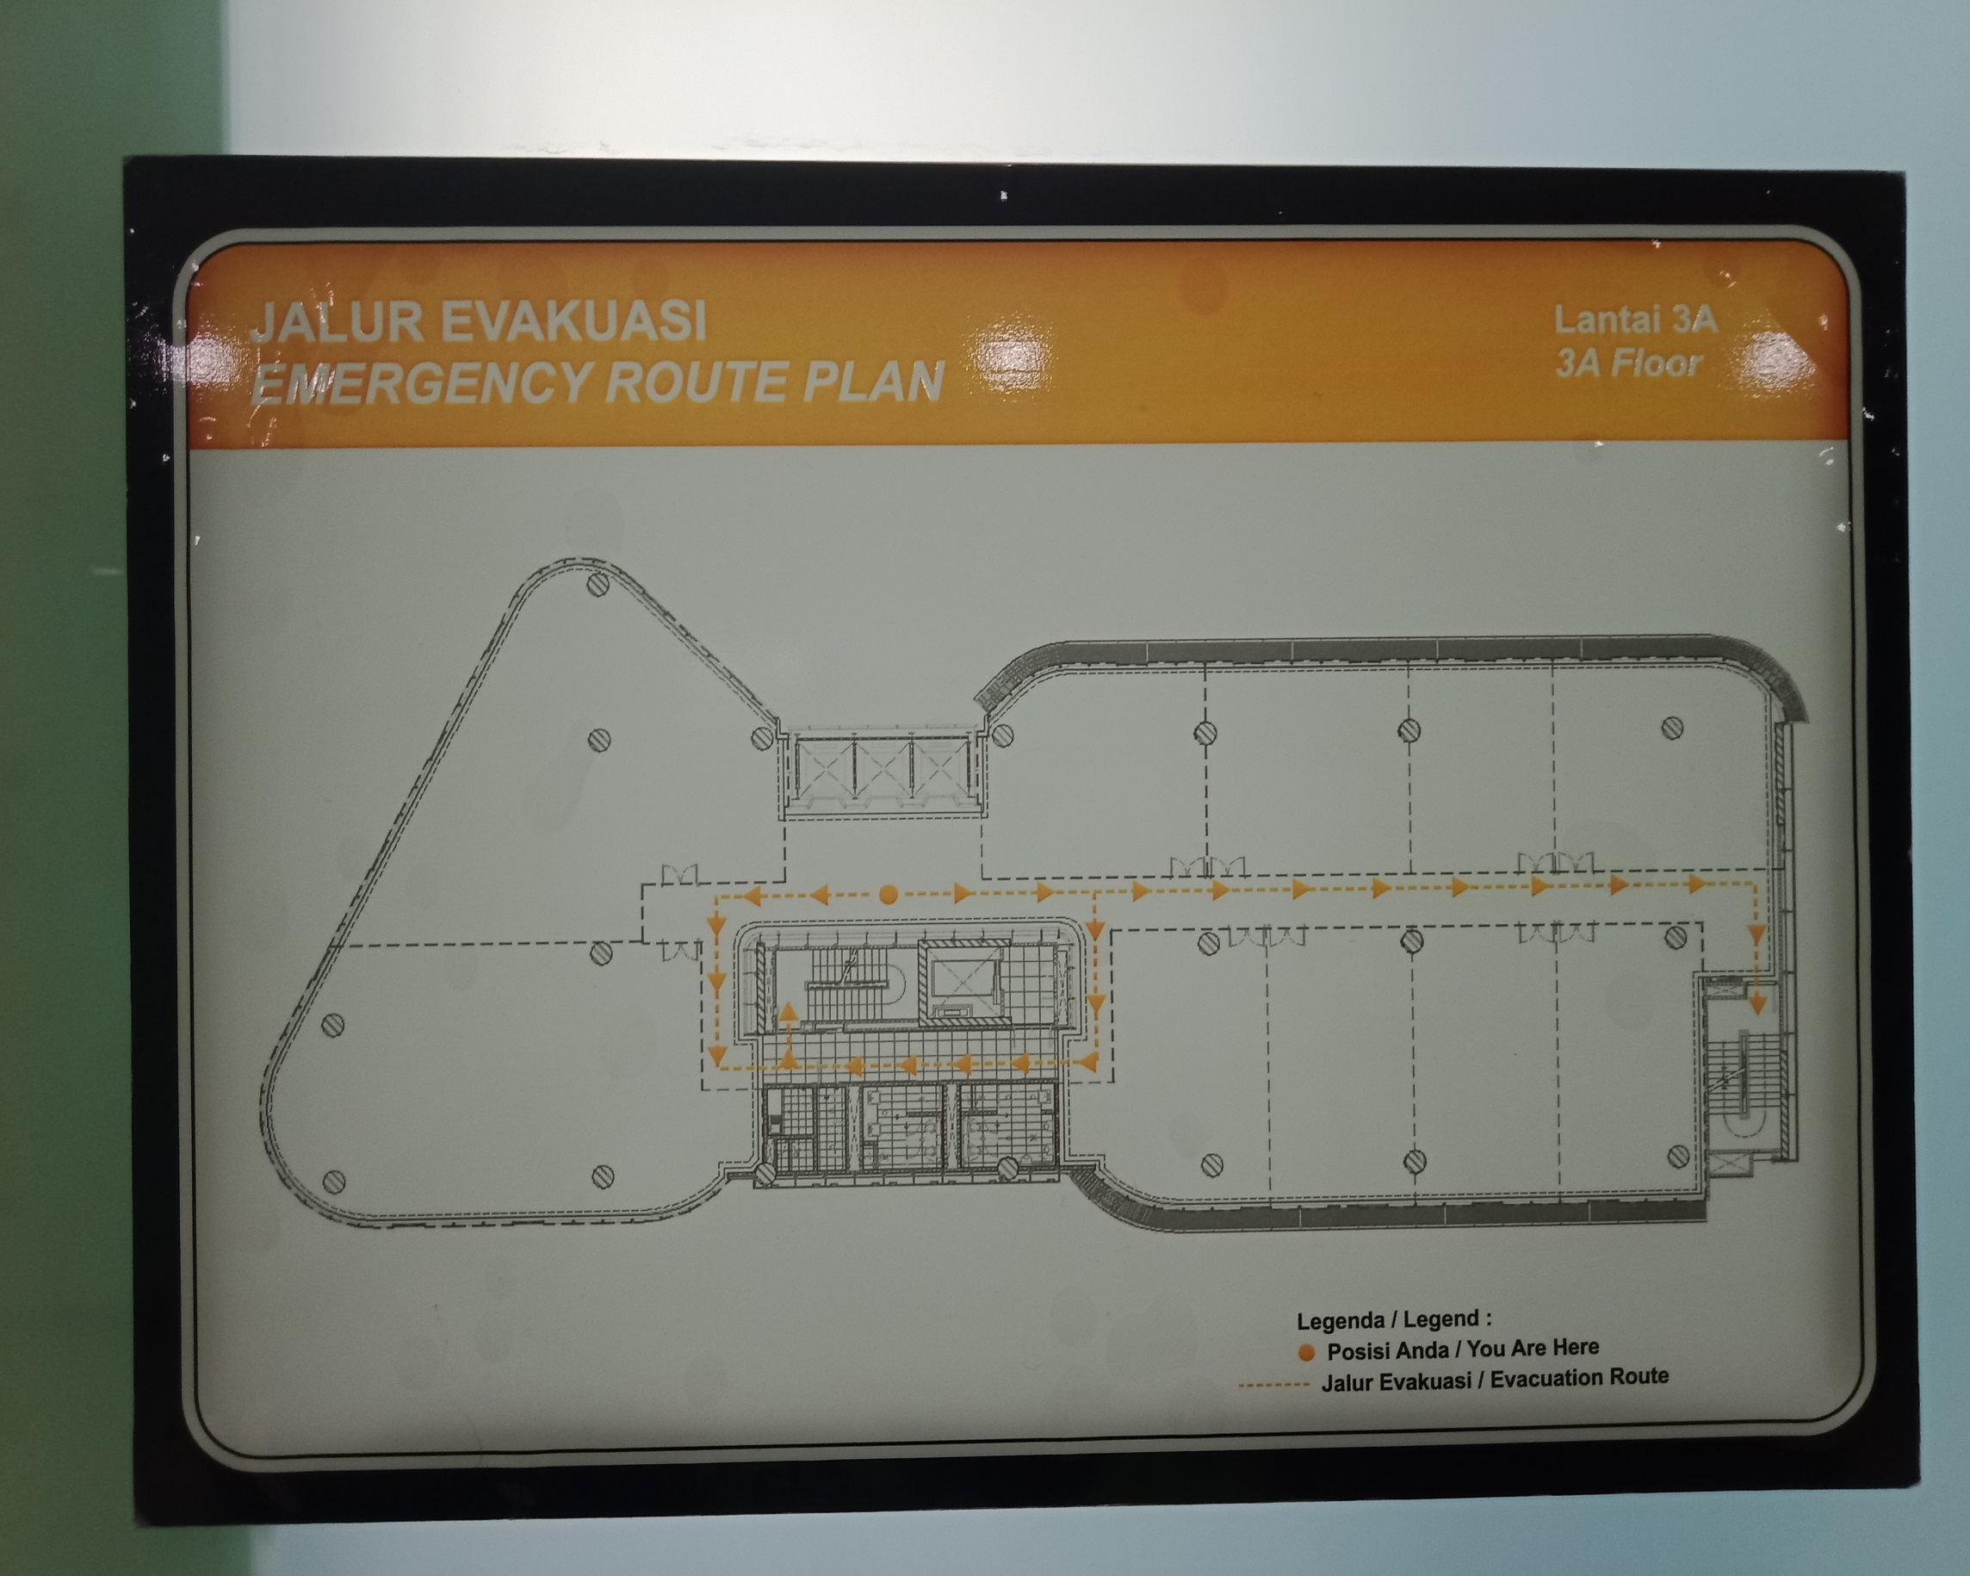

Titik GuardTour/

Exit Selatan

Titik GuardTour/

Ruang Pantry

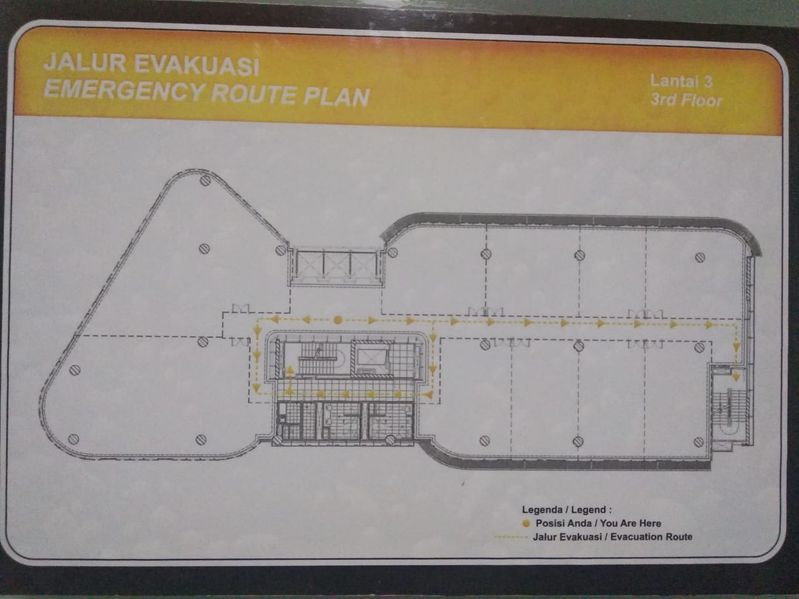

Titik GuardTour/

Exit Selatan

Titik GuardTour/

Ruang Pantry

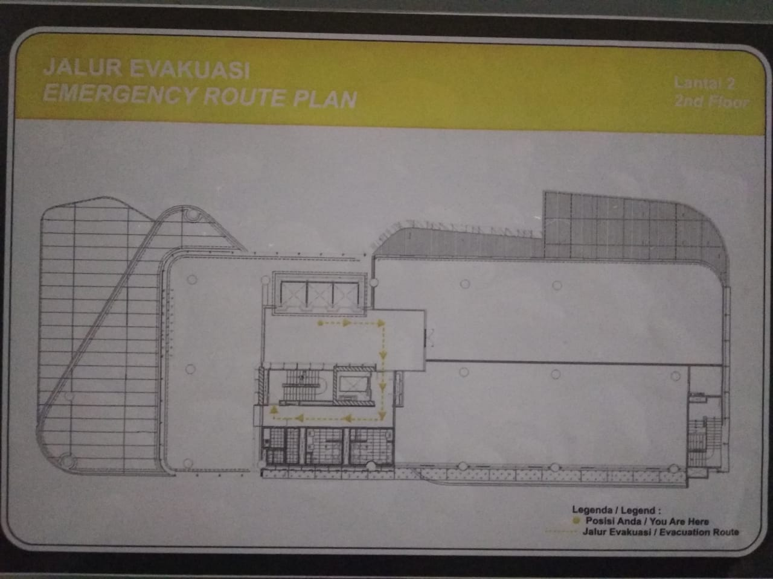

Titik GuardTour/

Depan Lift Service

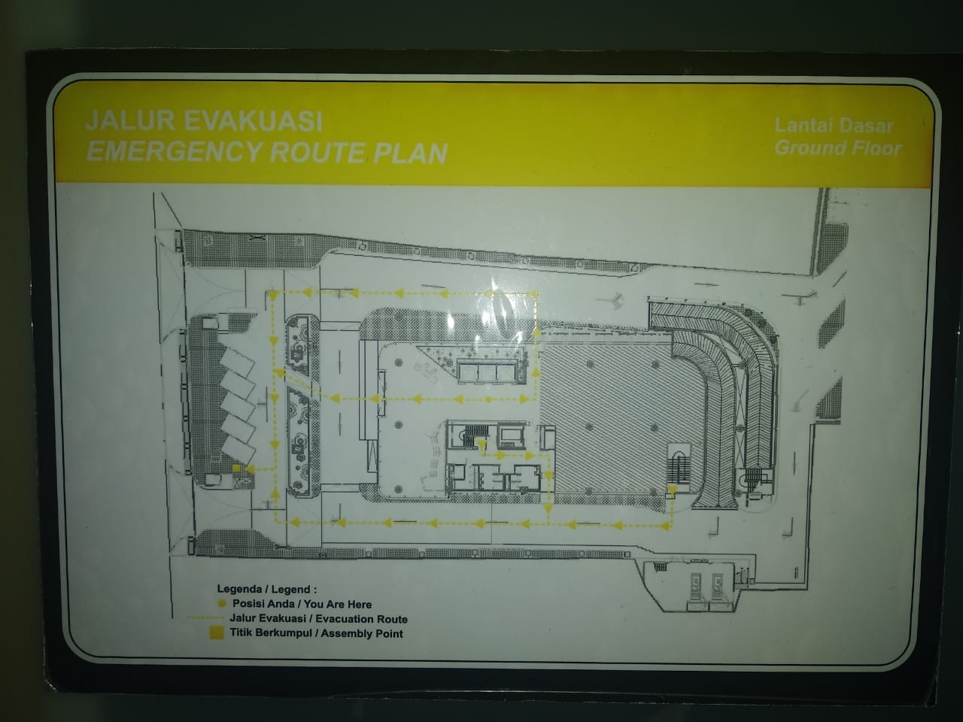

Titik GuardTour/

Tangga Ruang Genset

Titik GuardTour/

Parkiran Motor

Titik GuardTour/

Pos Pintu Masuk

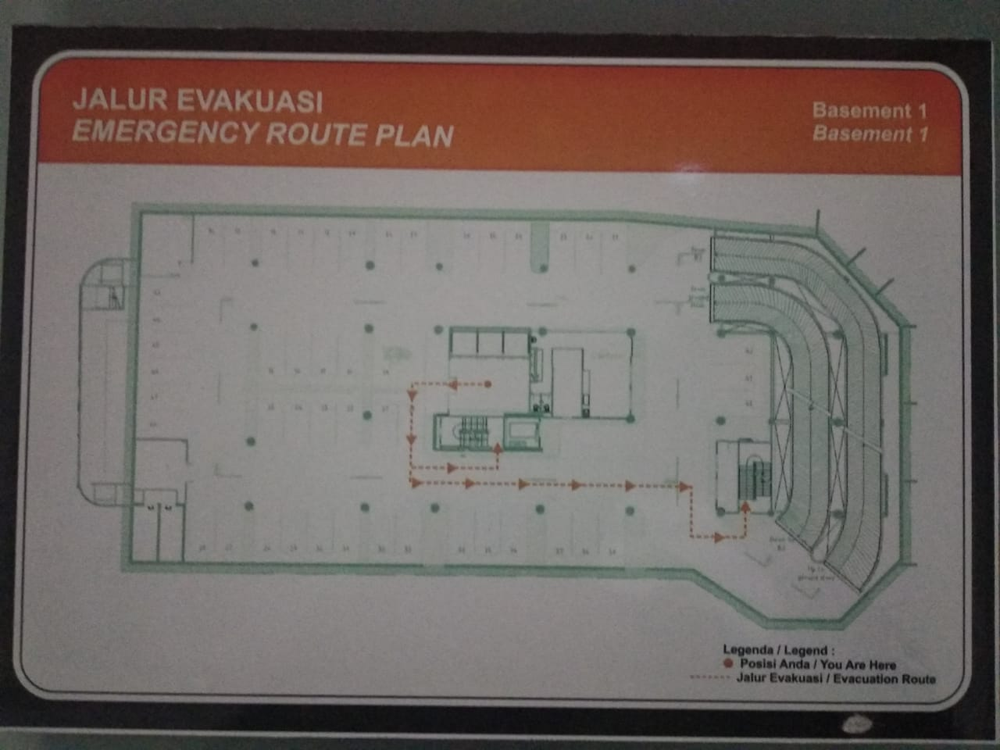

Titik GuardTour/

Ram Turun ke B2

Titik GuardTour/

Ruang Pompa

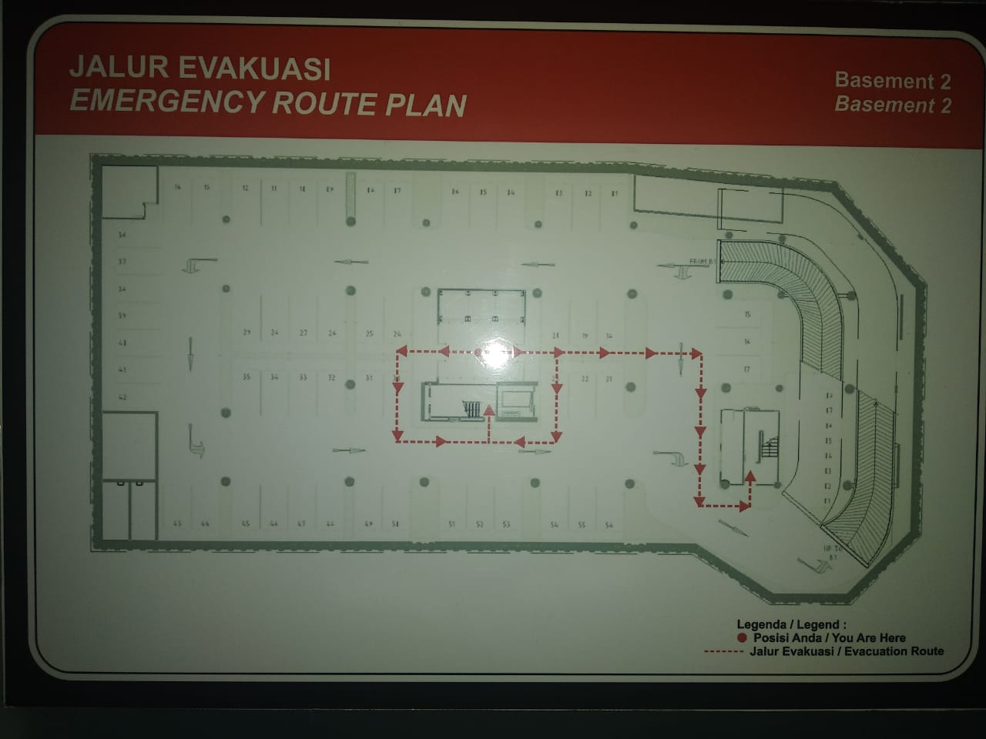

Titik GuardTour/

Ruang GPS (Sinyal)

Titik GuardTour/

Ruang STP

Titik GuardTour/

Exit Selatan

**POSISI TITIK GUARD TOUR DI AREA THE VIDA**

|  |  |  |  |  |
| --- | --- | --- | --- | --- |
| NO | LOKASI TTITK GUARD TOUR | AREA | | JUMLAH |
| 1 | ROOF TOP | SISI SELATAN DAN SISI UTARA | | 2 TITIK |
| 2 | LANTAI 10 | SISI SELATAN DAN FOYER | | 2 TITIK |
| 3 | LANTAI 9 | SISI EXIT UTARA/PANTRY | | 1 TITIK |
| 4 | LANTAI 8 | SISI EXIT UTARA/PANTRY | | 1 TITIK |
| 5 | LANTAI 7 | SISI EXIT UTARA/PANTRY | | 1 TITIK |
| 6 | LANTAI 6 | SISI SELATAN DAN SISI EXIT UTARA/PANTRY | | 2 TITIK |
| 7 | LANTAI 5 | SISI SELATAN DAN SISI EXIT UTARA/PANTRY | | 2 TITIK |
| 8 | LANTAI 3A | SISI SELATAN DAN SISI EXIT UTARA/PANTRY | | 2 TITIK |
| 9 | LANTAI 3 | SISI SELATAN DAN SISI EXIT UTARA/PANTRY | | 2 TITIK |
| 10 | LANTAI 2 | DEPAN LIFT SERVICE | | 1 TITIK |
| 11 | GROUND | PINTU MASUK | | 1 TITIK |
| 12 | GENSET | LANTAI 2 | | 1 TITIK |
| 13 | PARKIRAN BELAKANG | P.MOTOR UTARA | | 1 TITIK |
| 14 | BASEMENT 1 | RUANG POMPA,RAM TURUN B2 | | 2 TITIK |
| 15 | BASEMENT 2 | RUANG GPS, RUANG STP,EXIT SELATAN | | 3 TITIK |
|  | | | JUMLAH | 24 TITIK |

**RENCANA PENAMBAHAN TITIK GUARD TOUR AREA THE VIDA**

|  |  |  |  |  |
| --- | --- | --- | --- | --- |
| NO | LOKASI TTITK GUARD TOUR | AREA | | JUMLAH |
| 1 | LANTAI 9 | SISI SELATAN | | 1 TITIK |
| 2 | LANTAI 8 | SISI SELATAN | | 1 TITIK |
| 3 | LANTAI 7 | SISI SELATAN | | 1 TITIK |
| 4 | LANTAI 2 | SISI SELATAN | | 1 TITIK |
| 5 | PINTU KELUAR | POS SECURE PARKING | | 1 TITIK |
|  | | | JUMLAH | 5 TITIK |